Website Content Guidelines
After reading through these guidelines and create your website content, please send us your content using our website content submission form.

How to insert Images, Image Gallery, PDF and Video
Reference in red the name of the media file you want to insert or link to. You can also add a note regarding the layout or styling of the file. For buttons which link to webpages or downloads, highlight the text you want linked in green.
(Image2016.jpg) Float image left of text
https://www.youtube.com/watch?v=Xg1s8iADbCE&t=26s
Click here to download the flyer flyername.pdf
Before you submit your content, you will need to ZIP all files into a single zip folder. Please don’t place images in this word document.
Schoolzine will provide details for uploading files which exceed the 9MB email limit.

Parent & Child pages
Parent and child pages are used to indicate the navigation structure of your website. A web page may have both a parent and child pages.
A parent page is the top-level menu item which links to child pages. An example of a parent page displayed below is “Student Information”. It has 3 child pages.
A child page must be linked to a parent page. An example of a child page displayed below is “Uniform Price List”. This may also serve as a parent page if required.

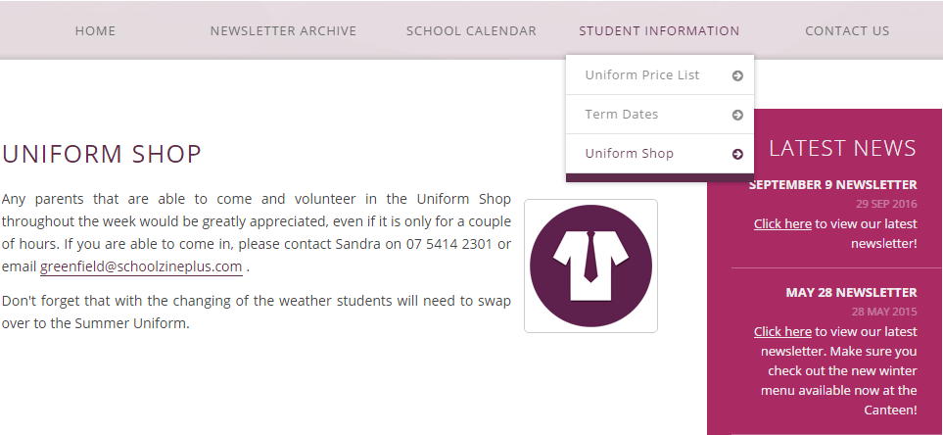

Website Content Example
Page Title * | Uniform Shop
Parent Page: | Student Information
Notes: | Anything else we should know about this page?

(uniform-shop.jpg) Float image right of text
Any parents that are able to come and volunteer in the Uniform Shop throughout the week would be greatly appreciated, even if it is only for a couple of hours. If you are able to come in, please contact Sandra on greenfield@schoolzineplus.com.
Don't forget that with the changing of the weather students will need to swap over to the Summer Uniform.

Website Content Template
Page Title * | All webpages must have a title
Parent Page: | Does this page link via another web page?
Notes: | Anything else we should know about this page?

