Schoolzine Website Pages Document
This document is provided to allow you to select the information you wish to be added to your new Schoolzine website. We ask that you fully read the following document.

Website Packages
Your school or organisation will have already selected a package allowing you 10 Schoolzine Built and Formatted Pages plus your Home Page, however there will be some template differences depending on the package that has been selected.
Please see the table below for more information:
HOP | SKIP | JUMP
Select one of our  Hop Templates | Customise your own using the Template Builder | Bespoke Home Page
*Please only fill out the relevant section below for your chosen website package*

Hop Template Options
Hop Template | eg. Template One
If you have purchased a Hop Template, view the options from our examples website and let us know which number Hop Template you wish to use:

Skip Template Options
If you have purchased a Skip Template, select the options for your template using The Template Builder and record your choices below for the various sections.
Note: Slider and Internal Page Slider options may be selected as none.
Section | Selection
Header | eg. One
Slider
Internal Page Slider
Footer

Jump Template Options
The jump package allows you to create a custom homepage template for your website. To give us a better understanding of how you would like the template designed, please fill out the website design questionnaire and submit it when returning this document via the Content Submission process.

Other Template Options
Other Template Options |  | Yes/No
Do you want a feed of latest news?

Would you like a news feed of your social media platform? (Facebook or Twitter)
If yes, please provide their full URL below:
Facebook: | Twitter:
Do you want news articles that link to your Schoolzine newsletter section appearing on the site?
(Schoolzine eNewsletter subscription required)
Do you want the slider to be populated by, and link to articles within your Schoolzine newsletter section?
(Schoolzine eNewsletter subscription required)
Please list any other items required that may affect the overall layout of the site:
(eg. Sponsorship Logos, Awards, Mandatory Education Department content etc)

System Pages
Please select the following system pages that you would like to be added to your new Schoolzine website. System pages are free and do not count towards the Schoolzine formatted pages limit included in your website package. If you are using other Schoolzine Services, our team may also have other system pages setup by default.
Yes/No | System Website Pages
YES | 1. Home Page
 | 2. Contact Us
 | 3. Absentee Form
 | 4. Schoolzine Calendar
 | 5. Subscribe

Website Navigation
To set up your website navigation, we use a system called Parent and Child pages.
For submission of your content, we will need you to label the pages as either a parent or child page.
- Parent Pages are pages that run along the top of your navigation.
- Child Pages are the pages that sit beneath the parent pages and relate to the Parent Page.
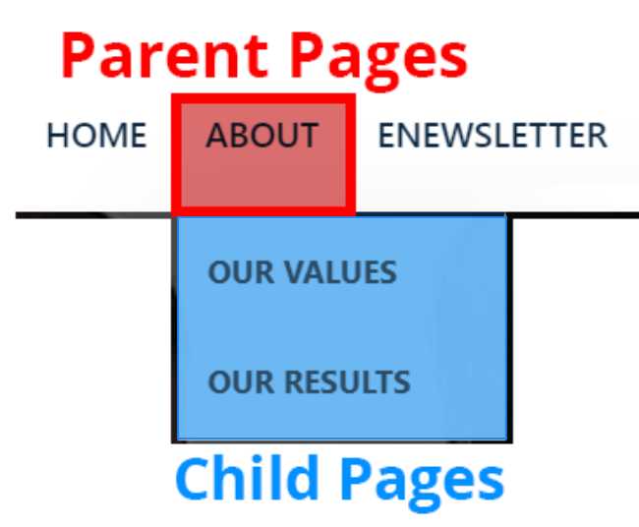

Schoolzine Formatted Pages
Please use the table below to inform us of the formatted pages you wish Schoolzine to set up.
Before the site goes live you may request access to build additional pages yourself at no extra cost. If you wish for Schoolzine to set up greater than 5 pages Schoolzine will complete this for a fee of $88 per page.

10 Pages Included | Schoolzine Formatted Pages | Parent/Child page?
 | 1.
 | 2.
 | 3.
 | 4.
 | 5.
 | 6.
 | 7.
 | 8.
 | 9.
Included | 10.
 | 11.
 | 12.
 | 13.
 | 14.
 | 15.
 | 16.
 | 17.
 | 18.
 | 19.
 | 20.
 | Add additional rows as required

Website Tiles
Website tiles are found at the base of the home page. Tiles are another way of linking to web pages, documents, newsletters etc. To view a working example of website tiles, view the demo account- Demo Account
Please label the tiles you wish to be added to your website homepage and the order in which you’d like them to appear from left to right.

Tile Heading | Tile Content | Tile Image name | Tile Link
EXAMPLE:  Forms & Documents | “Find our policy documents” | Students.jpg | Link to documents Page

1.

2.

3.

4.

5.

6.

7.

8.

9.

Final Notes
In order to give you the best first proof possible, Schoolzine will also need the following from you:
- Images for the slider. - Landscape images work best for the slider.
- Images you wish to be used for tiles.
- Any school colours/branding you wish to be added to the website.

Complete
Now that this Document is completed, please submit your content via the Website Content Submission Form along with any additional Images for sliders and tiles, your Colours, Branding and any other style guides and such that will assist our team. These can be submitted by combining them into a ZIP folder prior to submission.

